Te Hoe Rorohiko

Department of Business and Digital Technologies

Student Name ……Honglei Fu………………………………………………………

Student ID ………99240848…………………………………….

New Zealand Diploma in Information Technology Technical Support (Level 5) New Zealand Diploma in Web Development and Design (Level 5)

Database Design

DTEC502

Practical Assessment – SQL Test

Semester 1 2021

Date: **Friday, 11th June 2021**

Time: **8.00am – 10.00am**

Time Allowed: 2 hours 00 minutes Students are encouraged to read through the exam in the first ten (10) minutes and ask any questions.

Instructions:

Answer **ALL** questions.

This is an **OPEN** resources test.

Students are allowed to use their **OWN** resources.

All required files located on the DTEC502 Moodle site under the “FINAL SQL Practical Tests” tab.

**TOTAL MARKS:** 50

*Ara Institute of Canterbury and its division members reserve the right to use electronic means to detect and help prevent plagiarism.*

This test worth **25%** of the total marks for this course.

This assignment has eight (8) pages including the cover sheet.

--Q1

USE Clientorders

GO

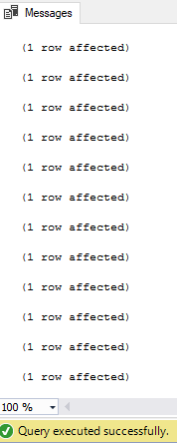

--Q2

SELECT [firstname], [lastname], [city]

FROM [dbo].[client]

WHERE [city]='DUNEDIN';

GO

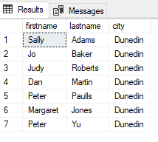

--Q3

SELECT [firstname], [lastname]

FROM [dbo].[client]

WHERE [lastname] LIKE 'J%';

GO

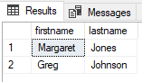

--Q4

SELECT [firstname], [lastname]

FROM [dbo].[client]

WHERE 50 <= [balance] AND [balance] <=150;

GO

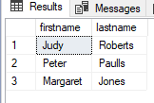

--Q5

SELECT [firstname], [lastname],[city]

FROM [dbo].[client]

WHERE [firstname]='Mary' AND [lastname]='Nelson';

GO

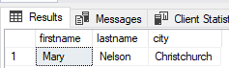

--Q6

SELECT [firstname], [lastname], [balance], [city]

FROM [dbo].[client]

WHERE [city]='DUNEDIN' AND [balance]<200;

GO

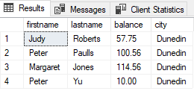

--Q7

SELECT [custref], [creditlimit], [balance], [creditlimit]-[balance] AS NewBalance

FROM [dbo].[client]

GO

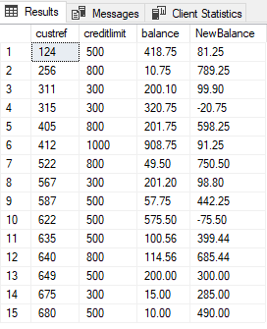

--Q8

SELECT [orderref], [partref], [quantity], [quotedPrice], [quantity]*[quotedPrice] AS 'LineTotal'

FROM [dbo].[orderline]

GO

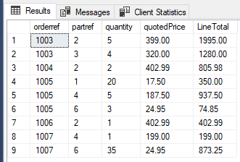

--Q9

SELECT [orderref], [orderdate]

FROM [dbo].[custorder]

WHERE [orderdate]>'1999-06-01';

GO

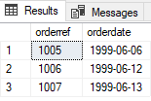

--Q10

SELECT [city], COUNT([custref]) AS 'Number in each city'

FROM [dbo].[client]

GROUP BY [city]

HAVING COUNT([custref])>3;

GO

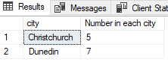

--Q11

SELECT [repref], SUM([balance]) AS 'Total balance'

FROM [dbo].[client]

GROUP BY [repref];

GO

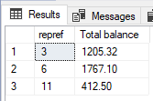

--Q12

SELECT [city], MAX([balance])

FROM [dbo].[client]

GROUP BY [city];

GO

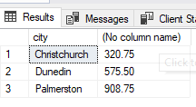

--Q13

SELECT [firstname]+[lastname] AS 'Client name', [RepFirstname]+[RepLastName] AS 'Rep Name'

FROM [dbo].[client],[dbo].[rep]

WHERE CLIENT.repref=REP.repref;

GO

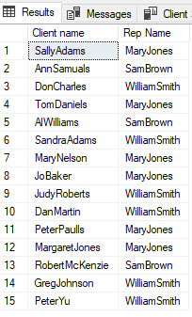

--Q14

SELECT [orderref], [firstname], [lastname], [orderdate]

FROM [dbo].[custorder], [dbo].[client]

WHERE custorder.custref=client.custref;

GO

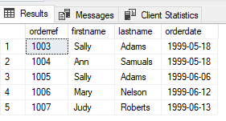

--Q15

SELECT [orderref], [description], [onHand]

FROM [dbo].[orderline], [dbo].[part]

WHERE orderline.partref=part.partref AND orderref='1007';

GO

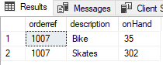

--Q16

SELECT [orderref], [description],[quotedPrice],[quantity]

FROM [dbo].[orderline], [dbo].[part]

WHERE orderline.partref=part.partref

ORDER BY [description];

GO

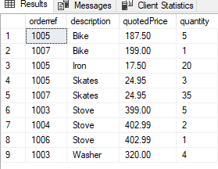

--Q17

SELECT [orderref], [description],[quotedPrice],[quantity]

FROM [dbo].[orderline], [dbo].[part]

WHERE orderline.partref=part.partref AND quotedPrice > 200

GO

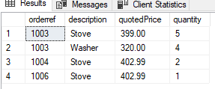

--Q18

SELECT orderline.orderref,[firstname],[lastname],[description],[unitPrice]

FROM [dbo].[custorder],[dbo].[client],[dbo].[part],[dbo].[orderline]

WHERE orderline.partref=part.partref

AND custorder.orderref=orderline.orderref

AND custorder.custref=client.custref;

GO

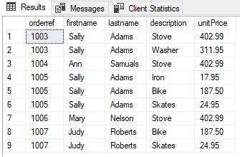

--Q19

SELECT orderline.orderref, [orderdate], [firstname],[lastname],[unitPrice]

FROM [dbo].[custorder],[dbo].[client],[dbo].[part], [dbo].[orderline]

WHERE orderline.partref=part.partref

AND custorder.orderref=orderline.orderref

AND custorder.custref=client.custref

AND [orderdate] > '1999-06-10';

GO

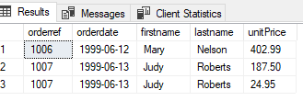

--20

SELECT orderline.orderref, [orderdate], [firstname],[lastname],[RepFirstname],[RepLastName],[description]

FROM [dbo].[custorder],[dbo].[client],[dbo].[part], [dbo].[orderline],[dbo].[rep]

WHERE orderline.partref=part.partref

AND custorder.orderref=orderline.orderref

AND custorder.custref=client.custref

AND CLIENT.repref=REP.repref;

GO

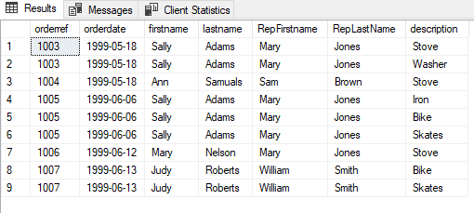

--Q21

SELECT [RepFirstname]+' '+[RepLastName] AS 'Rep Name', SUM([balance]) AS 'Total Blance'

FROM [dbo].[rep],[dbo].[client]

WHERE CLIENT.repref=REP.repref

GROUP BY [RepFirstname]+' '+[RepLastName]

ORDER BY SUM([balance])

GO

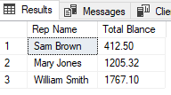

--Q22

SELECT [orderref], SUM([quantity]*[quotedPrice]) AS 'Total LineTotal'

FROM [dbo].[orderline]

GROUP BY [orderref]

GO

